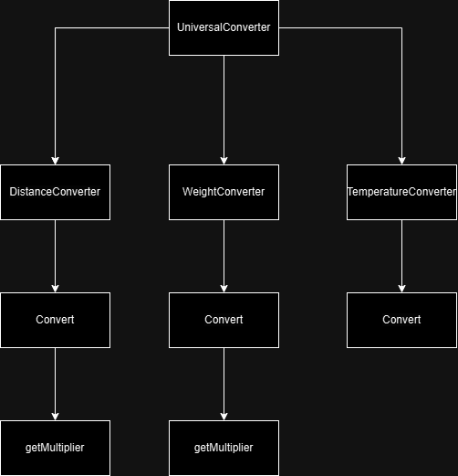

**Top-Down Integration Testing**

|  |  |
| --- | --- |
| Unit Under Test | List of Stubs |
| UniversalConverter | DistanceConverter, WeightConverter, TemperatureConverter |
| DistanceConverter | Convert |
| Convert | getMultiplier |
| getMultiplier | - |
| WeightConverter | Convert |
| Convert | getMultiplier |
| getMultiplier | - |
| TemperatureConverter | Convert |
| Convert | - |



**Bottom-up Integration Testing**

|  |  |
| --- | --- |
| Unit Under Test | List of Stubs |
| getMultiplier | Convert |
| getMultiplier + Convert | DistanceConverter |
| getMultiplier + Convert + DistanceConverter | UniversalConverter |
| getMultiplier | Convert |
| getMultiplier + Convert | WeightConverter |
| getMultiplier + Convert + WeightConverter | UniversalConverter |
| Convert | TemperatureConverter |
| Convert + TemperatureConverter | UniversalConverter |
| UniversalConverter | - |